STATS XENTE MANUAL INSTALLATION

# 1- Prerequisites

You need to install Tampermonkey as userscripts manager and is usefull pint it to the navigation bar of your browser.

# 2- Create New Script

# 

# 

Delete all code

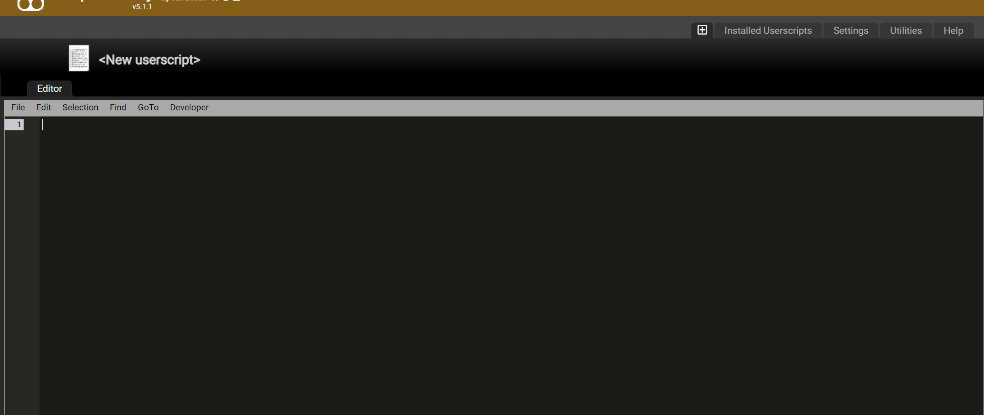

# 3-Copy/paste script code

<https://greasyfork.org/es/scripts/491442-stats-xente-script>

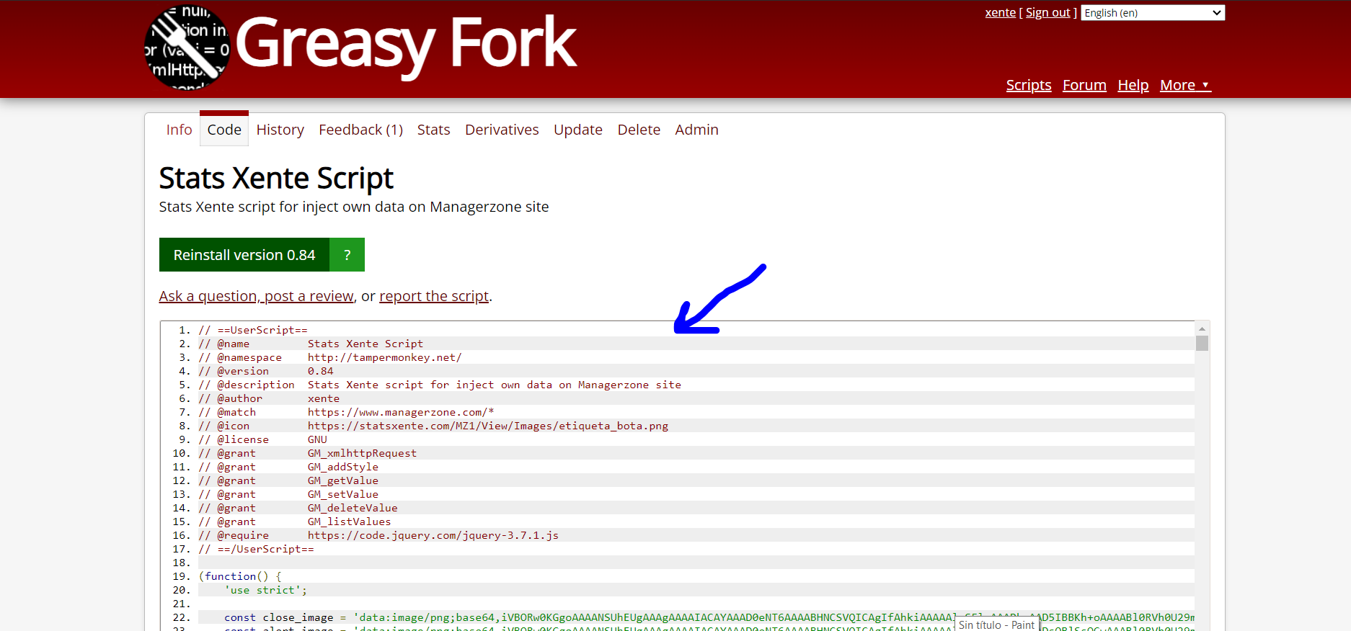Copy all code and paste on last screen, you can use CTRL+A to select all easy

If you have problems with Greasy Fork try with github link:

<https://github.com/alexgomezg/Stats-Xente-Script/blob/main/script_user.js>

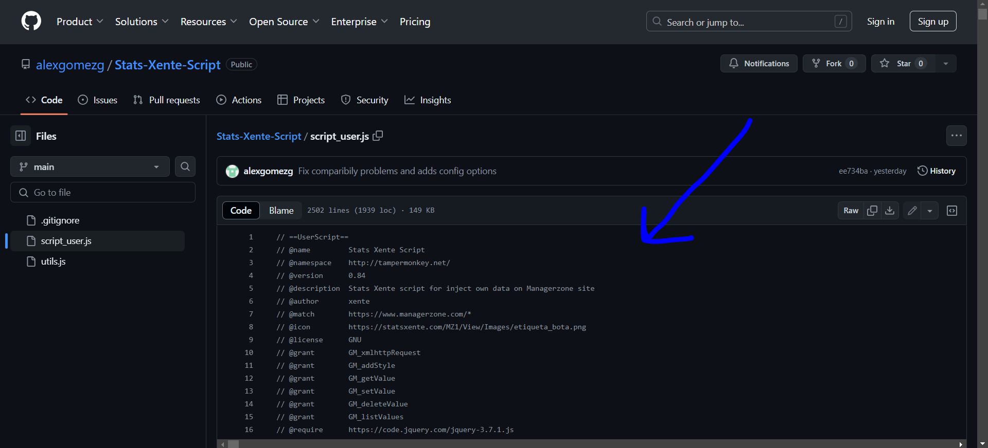

Copy and paste on last screen, you can use CTRL+A to select all easy

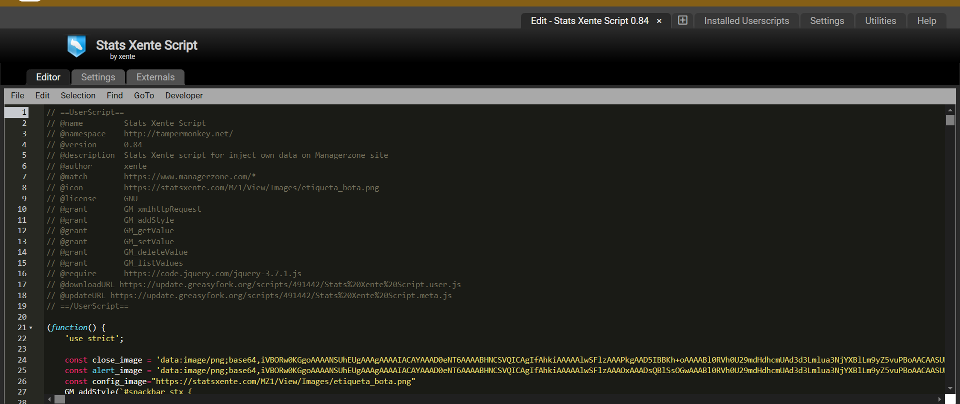

Use CTRL+S to save all, test on Managerzone page, probably you see the next two screen captures, please click in allow always domain to allow the connections to Stats Xente site.

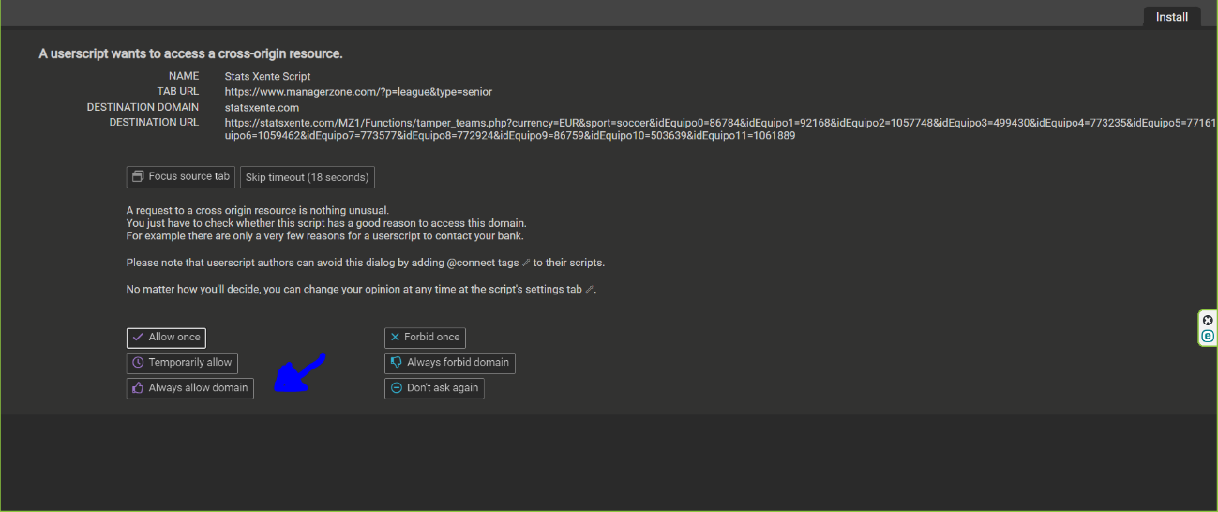

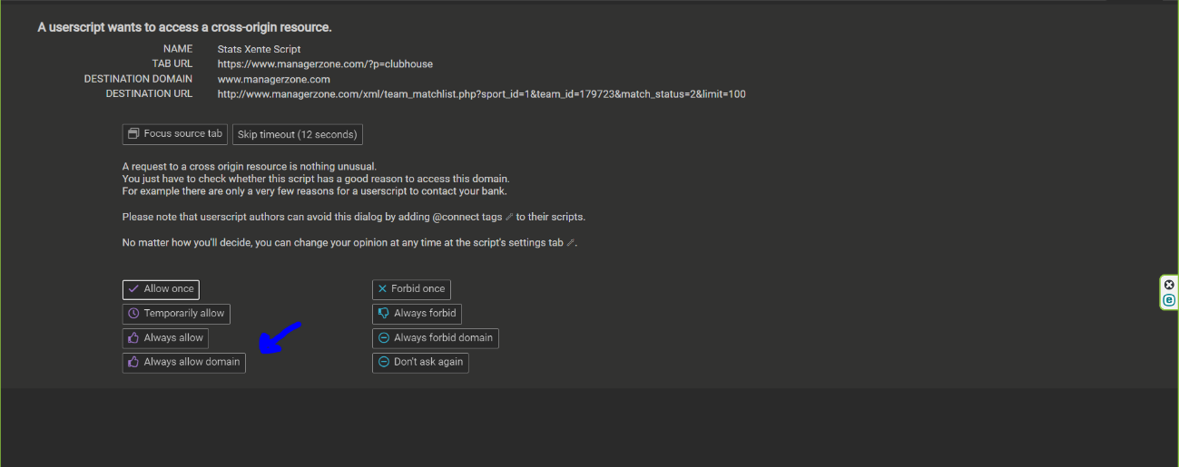

# 4-Allow domains

If after refresh the website the data not appears do this , Open Tampermonkey dashboard:

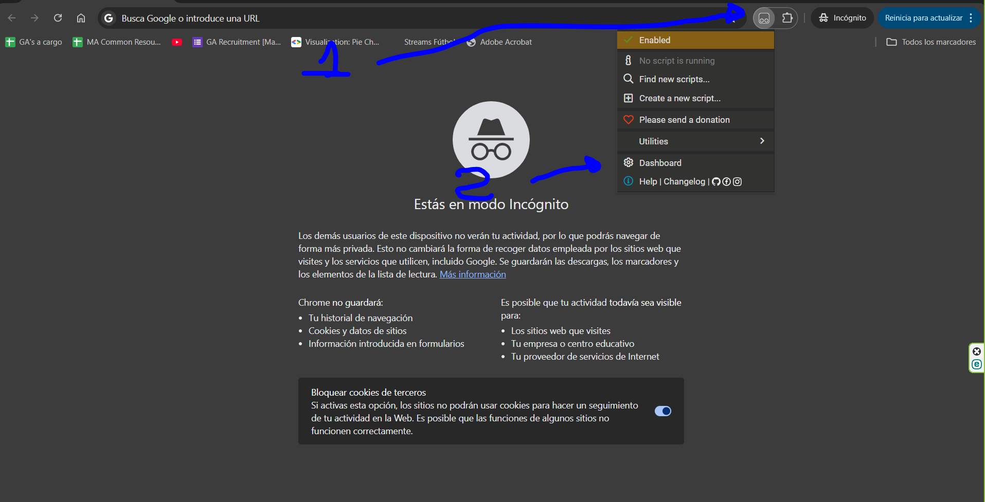

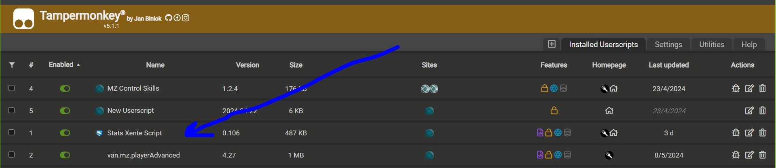

Click on Settings:

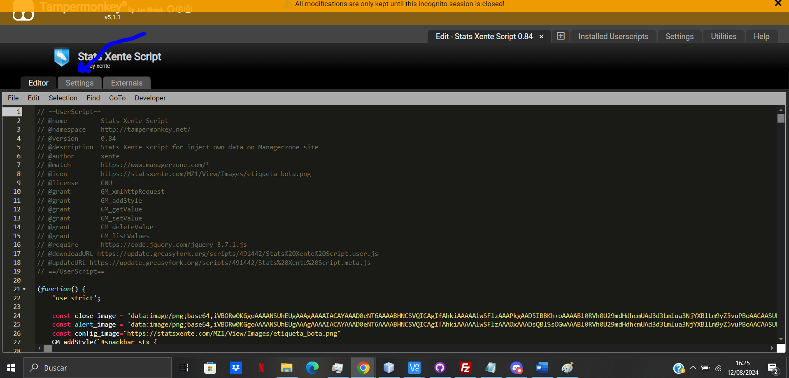

Go to bottom of page and add two domains to white list, **statsxente.com** and **managerzone.com**:

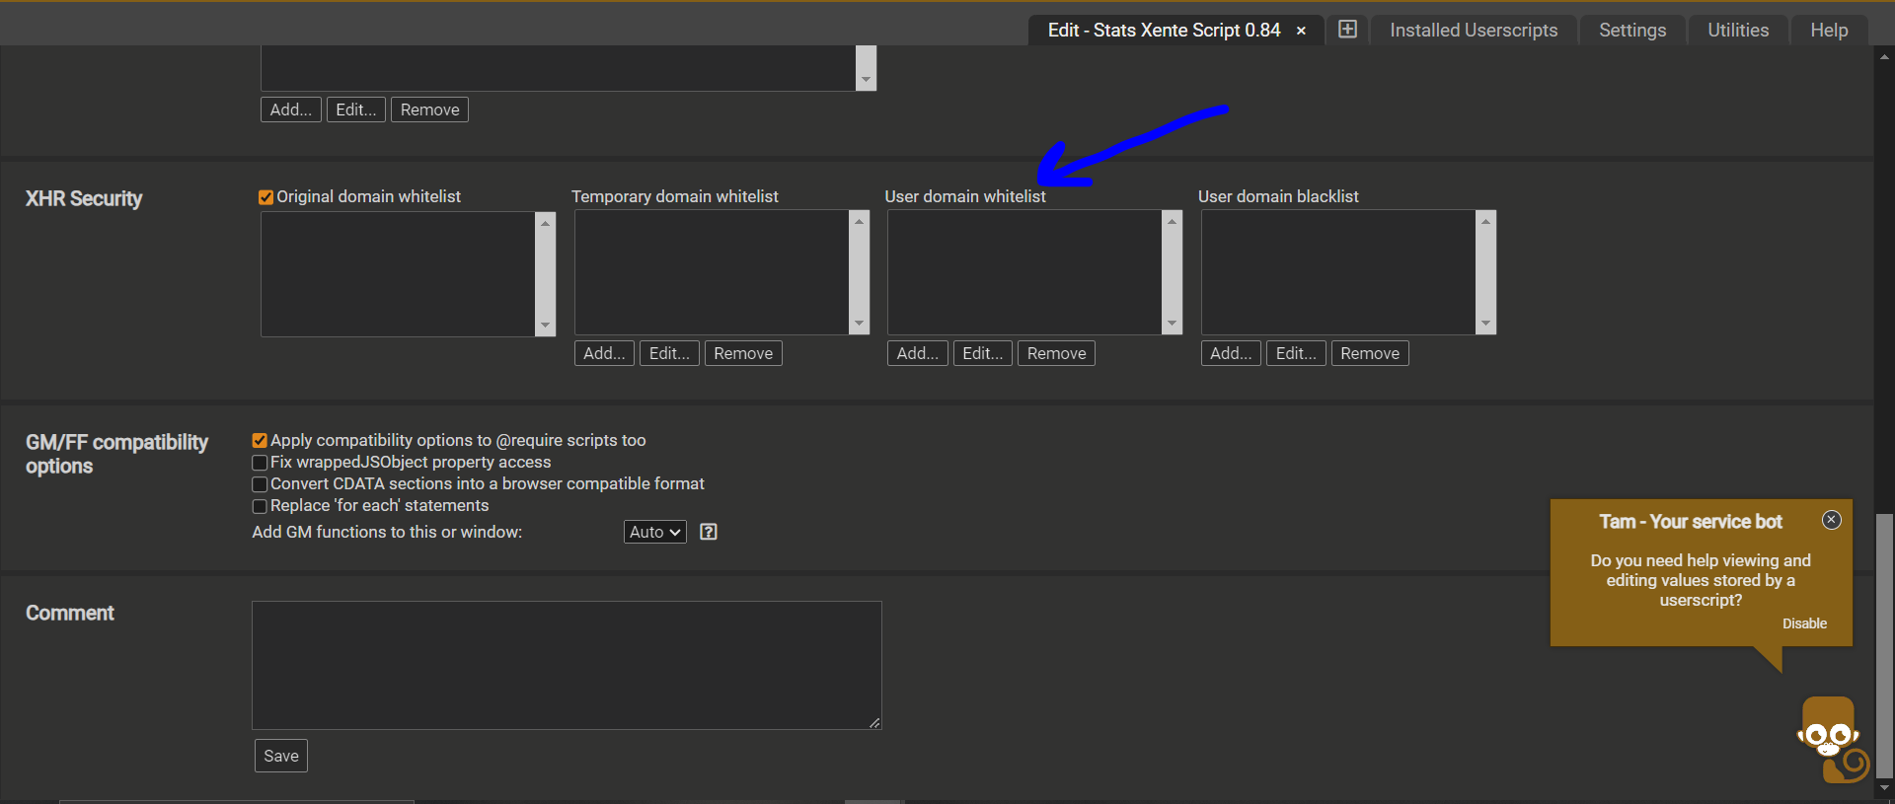

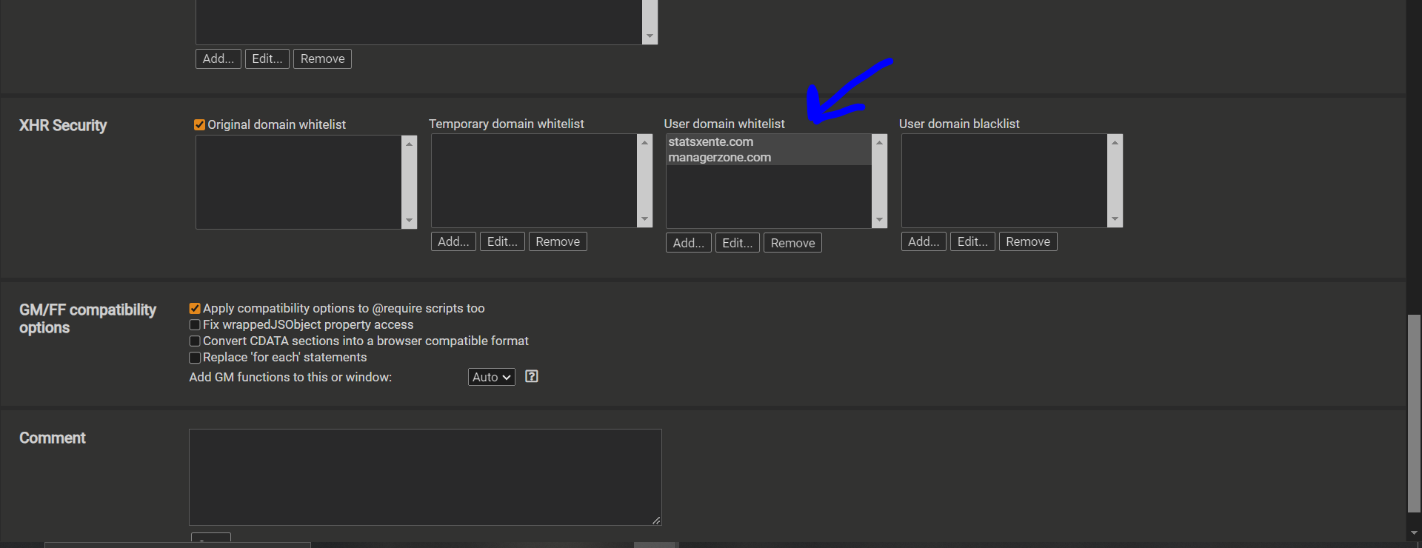

Refresh and try, if the extension still not working, please contact with xente else the script is correctly installed and the updated will be notified automatically.